Exercise 1: Configuring a Basic Spring Application
LibraryApplication.java
package com.library;
import org.springframework.context.ApplicationContext;
import org.springframework.context.support.ClassPathXmlApplicationContext;
import com.library.service.BookService;

public class LibraryApplication {
public static void main(String[] args) {
ApplicationContext context =
new ClassPathXmlApplicationContext("applicationContext.xml");
BookService service =
(BookService) context.getBean("bookService");
service.showBook();
}
}

OUTPUT
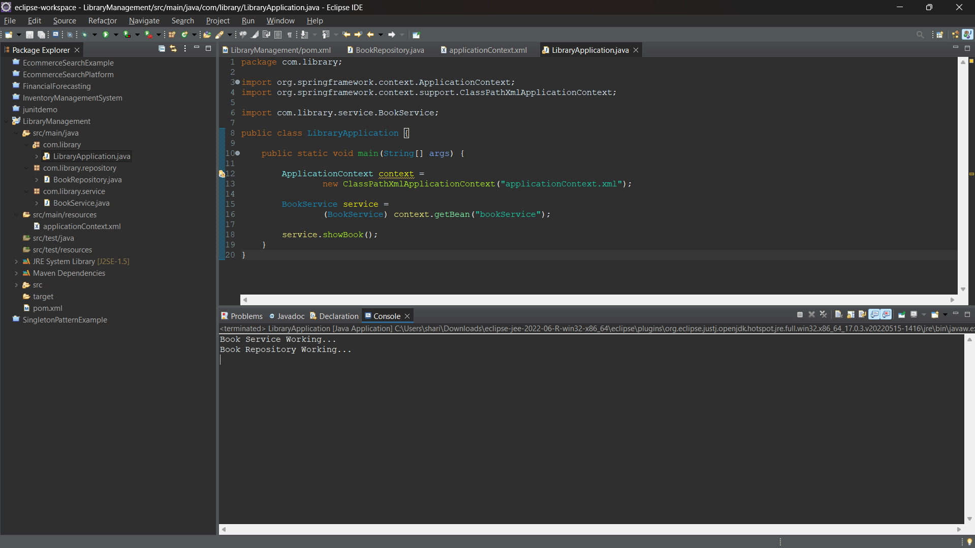

Exercise 2: Implementing Dependency Injection

OUTPUT
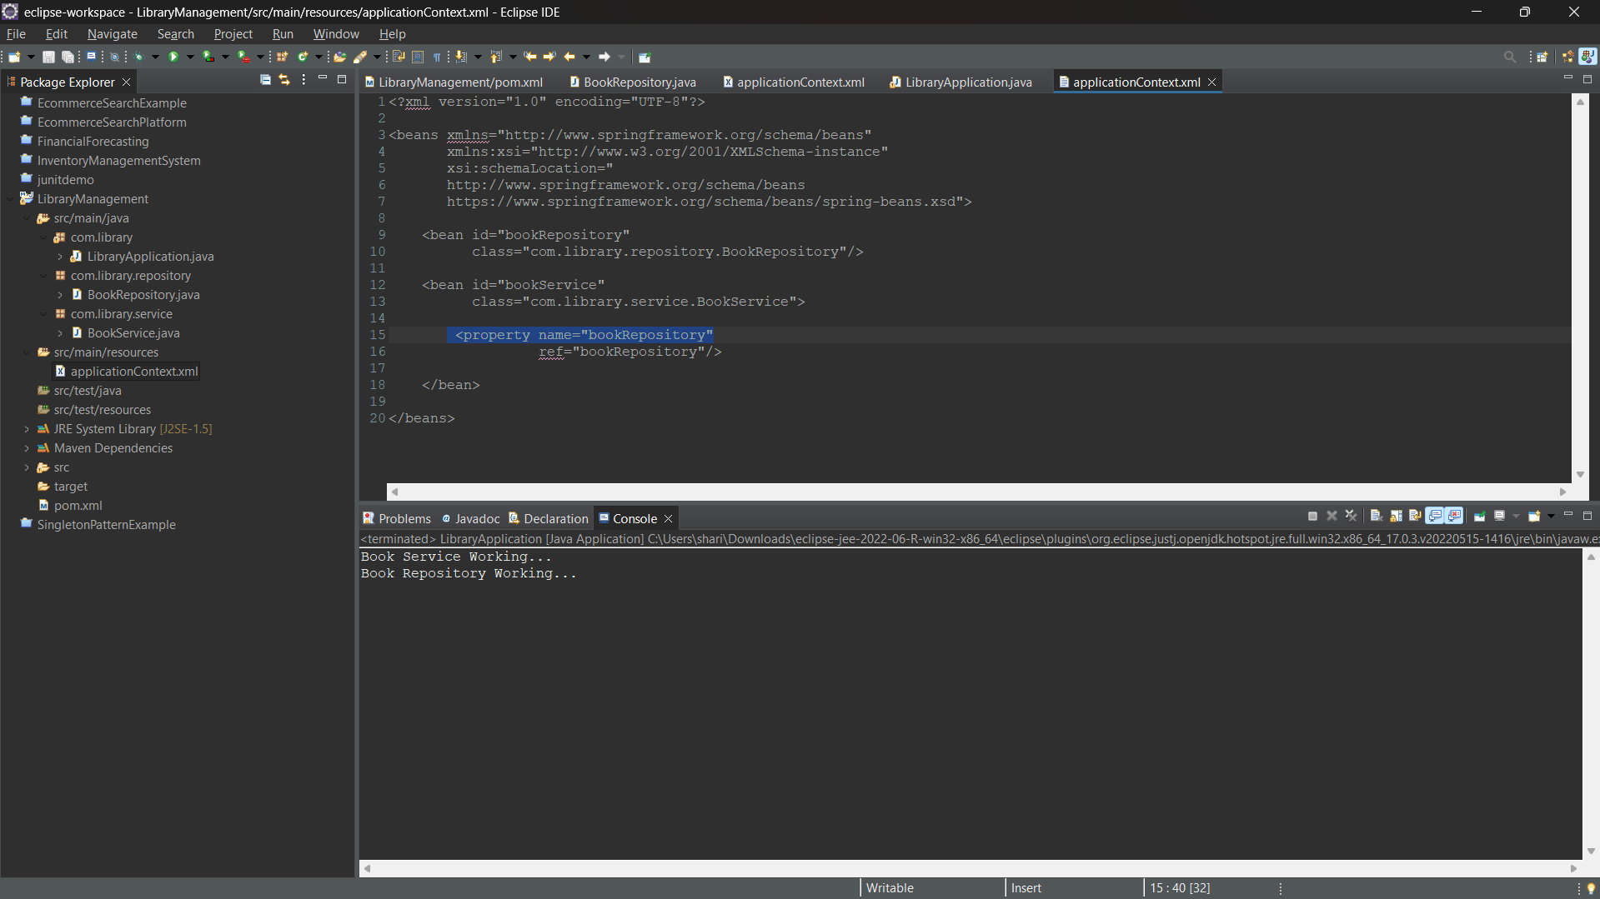

Successfully implemented Dependency Injection (DI) using Spring Framework. The BookRepository bean was injected into the BookService bean using Setter Injection through XML configuration. The application executed successfully and demonstrated Spring IoC Container functionality.

Exercise 4: Creating and Configuring a Maven Project

Maven Project Structure
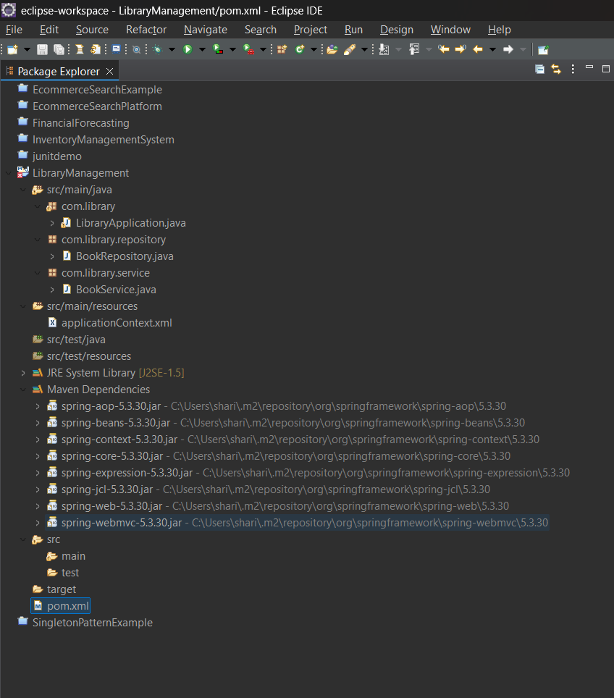

Pom.xml Dependency
<project xmlns="http://maven.apache.org/POM/4.0.0"
xmlns:xsi="http://www.w3.org/2001/XMLSchema-instance"
xsi:schemaLocation="http://maven.apache.org/POM/4.0.0
https://maven.apache.org/xsd/maven-4.0.0.xsd">

<modelVersion>4.0.0</modelVersion>

<groupId>com.library</groupId>
<artifactId>LibraryManagement</artifactId>
<version>1.0-SNAPSHOT</version>

<dependencies>

<dependency>
<groupId>org.springframework</groupId>
<artifactId>spring-context</artifactId>
<version>5.3.30</version>
</dependency>

<dependency>
<groupId>org.springframework</groupId>
<artifactId>spring-aop</artifactId>
<version>5.3.30</version>
</dependency>

<dependency>
<groupId>org.springframework</groupId>
<artifactId>spring-webmvc</artifactId>
<version>5.3.30</version>
</dependency>

</dependencies>

<build>
<plugins>

<plugin>
<groupId>org.apache.maven.plugins</groupId>
<artifactId>maven-compiler-plugin</artifactId>
<version>3.11.0</version>

<configuration>
<source>1.8</source>
<target>1.8</target>
</configuration>
</plugin>

</plugins>
</build>

</project>

